TRUSTEE’S MEETING
7.00 p.m. Tuesday 5th December 2023 Held at Crawcrook Pavilion
MINUTES
- Present: Laura Clark (Treasurer), Caroline James, Barbara Williams, Derrick Marrs, Sharon Dodds, Sue Welch, Chris Beer (Chair), Matt Broderick, and Penny Laverick.

- Apologies in advance: Kathryn Henderson, Norma Blackith, Stuart Lowerson

- Acceptance of minutes of previous meetings held on 7th November 2023 The committee confirmed acceptance of the previous meeting minutes. Laura to upload to the website (Action Laura).

- Greenside and Our Villages Constitution: Lengthy discussion about Crawcrook Village and relationship with Greenside village. Greenside has been part of Our Villages from the beginning. Currently no businesses engaged, but perhaps we should adopt a different approach to encourage more input and volunteer recruitment. Suggested an informal meet and greet date for potential volunteer’s end of January beginning February. (Action Chris) CB to reply to potential volunteers to keep them engaged until then. It was suggested that the 2024 summer fair could be held at the Cricket Club and a winter fair at Greenside Club. It would be useful to find out what community events are already on offer in the Greenside area in order to avoid clashes. (Action all) Further discussion at next meeting as part of priorities and objectives going forward.

- Financial matters:
  - Finance report and grant funding update: (LC) – Laura gave an update on the financial positions of each grant fund up to 30/11/23 and updated that year-end funds came to £32621.96.
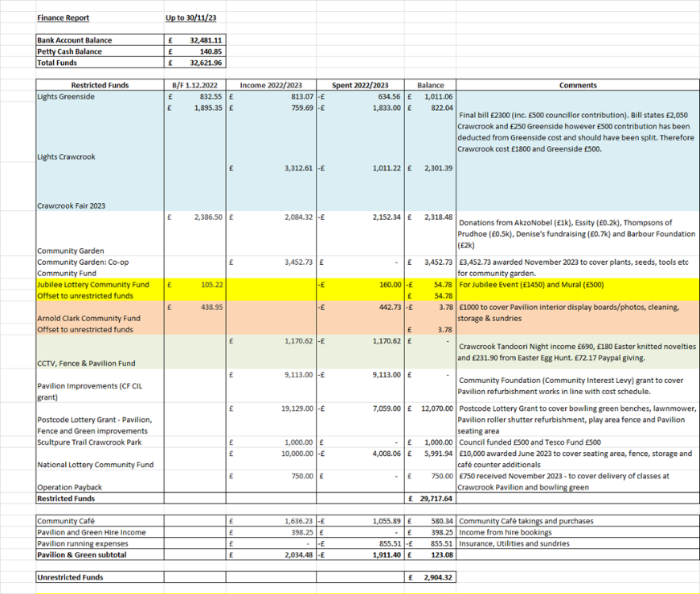
  - There are still funds available for the gardens, which will be utilised when the warmer weather arrives. The storage expenditure is extended to the end of June 2024.
- Crawcrook Pavilion & Green – Pavilion Subgroup Lead is Laura Clark
  - Pavilion works – joiner to be contacted after Xmas (Action Chris)
  - Community Café update – Derrick and Sharon agreed opening hours over the Christmas period. Have agreed to take the lead on organising and managing the Pavilion Pantry Café and to take into consideration perishable stock. Warm Spaces Training link had been sent out via the WhatsApp group. Food Hygiene Training can be undertaken on line. (Action Derrick and Sharon)
  - Pavilion and Green hire (LC) –Over the Christmas period, the café will be used to host photo sessions, a craft session and a Kids story telling session(s) with Chris Santa !!
  - Bowling Green update (LC) – No activity until Spring. Laura’s workplace colleagues may tidy up in the spring. (Action Laura).
  - Fence and storage updates. Still waiting fence quote from Kevin Hills, Gateshead Council. (Action Chris)
  - Sculpture Trail (CB) – to follow up (Action Chris)

- Review of regular activities:
  - Litter Picking:
    - No Issues.
  - Gardening:
    - General update: (SW) – reported that the pots had been frozen and flooded. The pinfold has been cleared for primroses and pansies.

- Community Garden Update (LC/BW)
  - Notes still stand from last meeting - The diocese are going to fund the benches for the seating area. One raised bed is being maintained by Emmaville School and the vegetables are growing strong. St Agnes have yet to commence maintenance of a bed. The remaining beds will be offered to local families/groups to maintain for 2 years. It was suggested the Willows nursery might be interested.
  - Access issues and gate (LC/BW) –Whilst Gateshead Council have currently refused a path and gate access to the garden, there was a site visit organised for the coming Saturday. As well as the church council being in support of the gate, Chris said he had a letter from Emmaville School supporting accessible access and a new gate. Chris would try to attend the site visit. (Action Chris)

- Recent and Upcoming Events – Event Subgroup Lead is Chris Beer

    - Christmas Tree Festival (decoration craft session), the Xmas Fair at Greenside Community Centre, Santa’s Grotto at the Pavilion, School choirs and the Christmas light switch all have been arranged for the festive period. A very special thank you to all involved in organising and volunteering at these events.
- A.O.B.:
    - Christmas meal for volunteers (All) – Chris has confirmed 25 people have paid to attend Hildrew’s café to have a Christmas buffet Tuesday 12th December from 6.30pm
    - Communications – Info still stands from last meeting re Newsletters, Open meetings and all member updates. – Trustees discussed quarterly open meetings starting in the spring, perhaps March. Topics might include visit from Police or Fire Services, as well as another recycling talk. These to correspond with a quarterly Newsletter, incorporating up and Coming Events. Penny to liaise with Tyne Valley Express Editor Steve for distribution in January 2024 if we have any events planned for the spring. (Action Laura/Penny)
UPDATE: email from Brighten Ryton inviting us to attend a meeting at Barmoor Hub 1pm Thursday 25 January 24 to discuss volunteers working together and identify what already happens and what the community want going forward.

Next scheduled Trustees meeting - Tuesday 9th January 2023 at 7.00 p.m. to be held in Crawcrook Pavilion.

