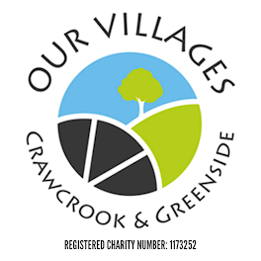

TRUSTEE’S MEETING
7.00 p.m. Wednesday 7th February 2024
held at Crawcrook Pavilion
MINUTES
- Present: Laura Clark, Sharon Dodds, Derrick Marrs, Barbara Williams, Caroline James, Sue Welch, Chris Beer (Chair), Julie Gavin, Kathryn Henderson

- Apologies in advance: Matt Broderick, Norma Blackith, Penny Laverick

- Did not attend: Stuart Lowerson

- Acceptance of minutes of previous meetings held on 9th January 2024 - The minutes were accepted by the Trustees present.

- Financial matters:
  - Finance report: (LC)

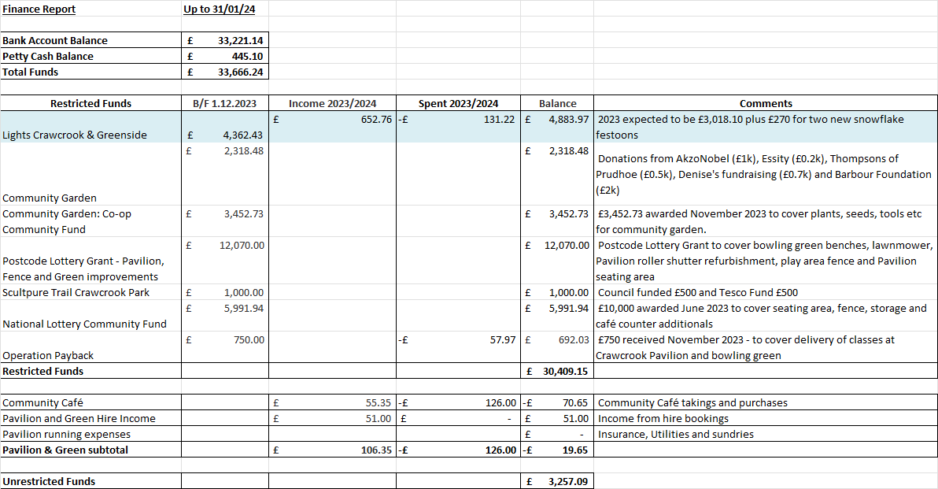

Postcode Lottery and National Lottery Grants to be spent by end of June 2024. Noted that Sindy Siddle who previously reviewed the year end accounts no longer works for Heritage Accountants, Laura will seek alternative quote from Our Gateshead.

- Crawcrook Pavilion & Green – Pavilion Subgroup Lead is Laura Clark
  - Pavilion works – The Café counter cannot be lowered until the CCTV box has been lowered. Chris and Derrick will arrange the lowering of the CCTV box which should allow the counter to be dropped up to 5 inches. The kitchen plinths and counter will be completed at the same time one weekend in February (Action Chris). Laura requested that the pictures also be rehung (Action Chris/Derrick).
  - Community Café update – The café has been quiet with the cold, wet and windy weather, expectation that trade will pick up with the Spring. Warm spaces to operate 12-4pm on a Wednesday with a free soups, teas and coffees on offer. AkzoNobel have granted £1,000 to cover delivering the warm spaces sessions. Laura to advertise warm spaces on Facebook (Action Laura).
  - Bowling Green update (/LC) – Laura has drafted the planning application, however, the application cost to submit is £642 which is deemed expensive. Kathryn is looking into the possibility of taking a second hand container from Gateshead Council and installing it in the compound instead, the planning application would then not be required. Our Villages would then stall the gazebo. (Action Kathryn to follow up with Gateshead Council Environmental & Leisure services). Once the spring arrives it would be possible to proceed with installing picnic benches in the bowling green (Action Chris/Laura).
  - Fence Update (CB) – Gateshead council have quoted £15.7k for Palisade fencing and £20.2k for Bow top fencing. As palisade fencing has a spiked top this is deemed inappropriate for a children’s play area, Chris will clarify the safety of the fencing with the council and see if any reduction could be made on cost (Action Chris to follow up).

- Review of regular activities:
  - Litter Picking:
    - General Update (SL) – Deferred to next meeting in Stuart’s absence, one new volunteer litter picker came forward in January.
  - Gardening:
    - General update: (SW) – The gardening angels activities have been hampered by the poor weather conditions, however, the tubs and pinfold are looking good. Some branches to be cut back following the high winds.

- Community Garden Update (LC/BW)
  - Update on progress (LC/BW) – Next garden meeting will be early March and no meeting held in February. It’s still hopeful that Newcastle Building Society will carry out a further volunteer session in the spring. Laura has advertised on facebook for applications from the community to take on management of 2 of the raised beds, one person has already expressed interest.
  - Access update – Paddy has drafted a response to the Council’s rejection for an access request. The letter addresses the Council’s concerns and demonstrates counter arguments. The group will no longer pursue a path only an access gate from the park. It was noted the current access is unappealing which is against the ethos of a welcoming garden, there is a gradient to the front of the church which makes disabled access trickier, and the gates are often blocked by cars which can make it unsafe for children/disabled users.

- Greenside Volunteers: Caroline, Derrick and Sharon met with Hayley who has shown interest in volunteering with Our Villages, one further interested person didn’t show. Hayley is also involved in Greenside Matters solar panel campaign and has a good network of contacts. She is keen to reinstate the Greenside litter picks which previously took place 3 times per year. Chris will message to arrange a follow up and also contact the other person to see if they’re still interested (Action Chris).

- Upcoming Events – Event Subgroup Lead is Chris Beer
      - Easter Egg Hunt – Date set 30th March 2024 10-12pm with the pavilion café open 10-1pm. Asda and Liz Twist have already confirmed they’ll donate eggs, Caroline will update the letters to businesses with Rachel will distribute. Baking donations of cakes, scones and traybakes would be welcomed to sell in the café on the day.
      - Charity Curry Night – February 6th event was cancelled due to poor bookings, potentially to be rearranged for a later date however it was noted the menu options don’t offer much choice and don’t represent good value for money. Alternative theme nights at Hildrew’s café to be considered (Action Chris to follow up).
      - Jumble Sale – To avoid having lots of donations that Our Villages then need to find homes for it’s proposed that tables be offered at a cost of £15-£20 and each table owner takes responsibility to removing any unsold items. Our Villages could then have a table and also sell refreshments in the pavilion café. Consider using the church hall (Action Laura to check dates with Margaret) or use the pavilion/patio.
      - Funday/Fair – No one is keen to lead management of the fair preparations and event paperwork. If an event is to go ahead event paperwork needs to be submitted 12 weeks prior, if we’re aiming for a September ‘Back to school’ fair then paperwork should be submitted by start of June. If we proceed with an event stall bookings would be handled directly as it was noted Eventbrite fees are substantial.

- A.O.B.:
    - Partnership Network Update – Caroline attended the partnership meeting in Barmoor Hub. There were representatives from lots of local community groups. The intention is to put together a directory to allow the public to volunteering opportunities etc easily and help groups work together. The partnership has possibilities but needs to be mindful not to dilute other groups’ services. A further meeting is to be arranged.
    - Dog training – Karen Horner had requested whether the green could be hired for dog exercising, the committee are keen to keep the green clean and free of dog fouling therefore this has been rejected.
    - Petition – Chris is arranging a petition to lobby Gateshead Council to install matting on the green area at the back of the park to allow safer parking. Committee agreed Chris could submit the petition in the name of Our Villages.
    - Woodland trust tree application – Barbara has been successful in her application for hedglings which will be delivered in November. Suggestion to have a community planting day and combine with other activities and refreshments. The ground in the bowling green would need to be prepared prior to planting. Could also look to make Christmas decorations from collected natural materials. To be included in the October agenda for further discussion and planning (Action Penny).

- Date and time of next meeting(s):
    - Next scheduled Trustees meeting - Tuesday 5th March 2024 at 7.00 p.m. to be held in Crawcrook Pavilion.

