TRUSTEE’S MEETING
7.00 p.m. Tuesday 7th November 2023 Held at Crawcrook Pavilion
MINUTES
- Present: Laura Clark (Treasurer), Caroline James, Barbara Williams, Derrick Marrs, Sharon Dodds, Sue Welch, and Penny Laverick.

- Apologies in advance: Norma Blackith, Chris Bee (Chair), Matt Broderick, Stuart Lowerson

- Did not attend: Kathryn Henderson

- Acceptance of minutes of previous meetings held on 3rd October 2023. The committee confirmed acceptance of the previous meeting minutes. Laura to upload to the website (Action Laura).

- Financial matters:
  - Finance report and grant funding update: (LC) – Laura gave an update on the financial positions of each grant fund, which includes £ 3.6k for the Christmas lights this year.
  - It was noted that the Bird Feeder/Halloween trail event made £80.50 (£30.05 profit)
  - Trustees discussed using funds to update the toilet area in the Pavilion as well as the other already agreed improvements.

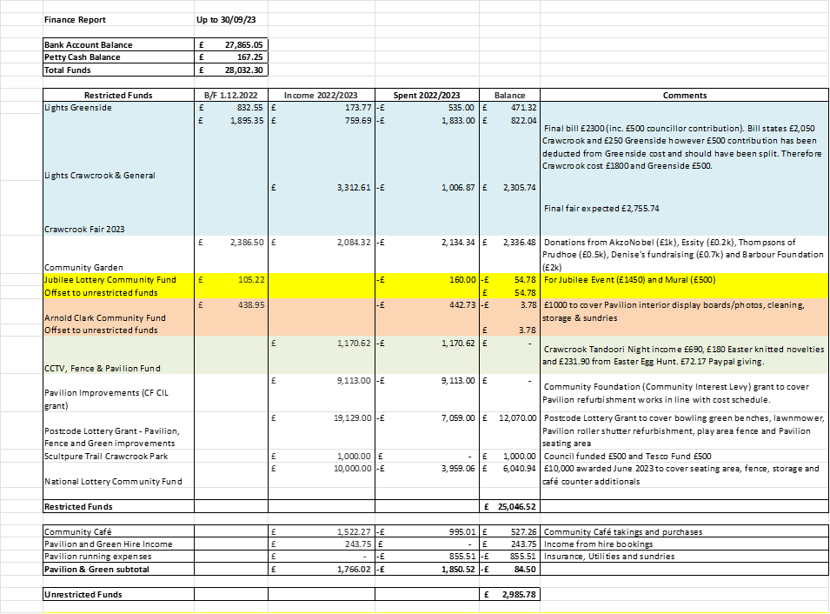

- Crawcrook Pavilion & Green – Pavilion Subgroup Lead is Laura Clark
  - Pavilion works – Joiner works for plinths, ramp and café counter. Still awaiting work to be completed. (Action Chris)
  - Community Café update – Derrick and Sharon have agreed to take the lead on organising and managing the Pavilion Pantry Café. They have decided to trial working different days to see what works Wed/Thurs/Frid and extend opening over the summer period again to 5 days. Discussed Warm Spaces and opening Tuesdays for this. Important to consider perishable stock. Food Hygiene Training can be undertaken on line. (Action Derrick and Sharon)
  - Pavilion and Green hire (LC) – The chair yoga is still the only regular hire currently. The Library rhyme time group will be hiring the pavilion in the New Year whilst the library is unavailable. Over the Christmas period, the café will be used to host photo sessions and a potential wreath workshop.
  - Bowling Green update (LC) – Due to the inclement weather over the last few weeks, it was decided to wait until spring/better weather to tidy the bowling green and flower beds. Chris is still going to ask Network Rail for available volunteers when the time is right, and look into Tarmac for volunteer support. (Action Chris).
  - Fence and storage updates. Still waiting fence quote from Kevin Hills, Gateshead Council. A reminder that Our Villages could also source and fit the fence if we find a suitable contractor. (Action Chris) Barbara to take Gazebos from the lock up back to the Council. Caroline requested that items she has at home could be taken to the lock up once there is space cleared.
  - Classes Pavilion/Green (LC) – Suggestions still stand from last meeting, namely; to look into running sessions in the Pavilion and on the Green once the better weather returns subsidised by the Operation Payback fund in order to make them free to the attendee. Options to consider are First Aid, Police Home Security, Fire Safety, Sign posting local clubs and sports groups, Board Game evenings/afternoons, adult graffiti art classes, DJ introduction. Another idea added was self-defence.

- Review of regular activities:
  - Litter Picking:
    - General Update (SL) – Deferred to December meeting.
  - Gardening:
    - General update: (SW) – Bad weather has had an impact on gardening activities, and many of the tubs were water logged. However, baskets have been refreshed, and some shrubbery tidied up. The Gardening Angels continue to do sterling work around the village to keep it looking smart.
    - Penny will help create a fernery and rockery re-using some of the rocks and logs we already have once the bed has been cleared in the spring. (Action Penny).

- Community Garden Update (LC/BW)
  - Notes still stand from last meeting - The diocese are going to fund the benches for the seating area. 1 raised bed is being maintained by Emmaville school and the vegetables are growing strong. St Agnes have yet to commence maintenance of a bed. The remaining beds will be offered to local families/groups to maintain for 2 years. It was suggested the Willows nursery might be interested.
  - Access issues and gate (LC/BW) –Whilst Gateshead Council have currently refused a path and gate access to the garden, there will be a site visit in December by Councillors and we will await the outcome of their discussions. It is noted that the church council is in support of the gate.

- Recent and Upcoming Events – Event Subgroup Lead is Chris Beer

      - Halloween crafts/activity trail Tuesday 31st October 1-3pm (LC) – The event feedback received from participants was good. The children really enjoyed the activities and a small profit from sales was made on the day
      - Autumn Fair – Greenside Community centre date 18th November 2023 (CJ)
A good selection of stalls will attend on the day as well as a raffle and children’s activities. Well advertised via Facebook poster. Event volunteers are organised for set up and running of the event.
      - Christmas Tree Festival (decoration craft session) will take place on 21st November 10am – 12pm in the Pavilion. Advert to be posted on Facebook (Action Judy/Laura).
      - Christmas Lights Switch on (CJ/CB) – Crawcrook light switch on is planned for 6th December. Greenside 7th December along with a children’s choir hopefully.
      - Christmas Grotto @ Pavilion – cake/coffee with Santa, stories with Santa (LC) –. There will be two x sessions on Monday 11th December aimed at younger children with Santa reading Christmas stories and Christmas activity. All to see if we have any spare decorations to make the event bright and cheerful. We can borrow a backdrop form the photoshoot person. Christmassy refreshments will be served. (Action Laura and Chris).

- A.O.B.:
    - Christmas meal for volunteers (All) – Chris has confirmed with Hildrew’s café to have a Christmas buffet Tuesday 12th December from 6.30pm, cost of £12.50 per person to be paid to Chris by 15th November. Number so far confirmed at this meeting is 21 people. (Action All).
    - Greenside and Our Villages Constitution - It was agreed that this is an important subject, which will need to be on the main agenda at the next meeting rather than A.O.B. The question was whether to hand over the organising and fundraising of Greenside Christmas Lights to an amenable and appropriate organisation based in Greenside. This will enable us to concentrate our charitable funded activities solely on the Crawcrook community, as events in the village are expanding to take up the majority of volunteer capacity.
    - Communications – Newsletters, Open meetings and all member updates. – Trustees discussed quarterly open meetings starting in the spring, perhaps March. Topics might include visit from Police or Fire Services, as well as another recycling talk. These to correspond with a quarterly Newsletter, incorporating up and Coming Events. Penny to liaise with Tyne Valley Express Editor Steve for distribution in January 2024 if we have any events planned for the spring. (Action Laura/Penny)

- Date and time of next meeting(s):
Next scheduled Trustees meeting - Tuesday 5th December 2023 at 7.00 p.m. to be held in Crawcrook Pavilion.

