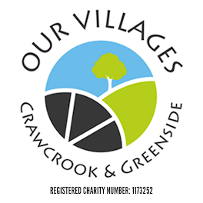

TRUSTEE’S MEETING
7.00 p.m. Tuesday 9th January 2024 Held at Crawcrook Pavilion
MINUTES
- Present: Laura Clark (Treasurer), Caroline James, Barbara Williams, Derrick Marrs, Sharon Dodds, Sue Welch, Chris Beer (Chair), Matt Broderick, Norma Blackith, Julie Gavin and Penny Laverick.

- Apologies in advance: Stuart Lowerson

- Acceptance of minutes of previous meetings held on 12th December 2023 the committee confirmed acceptance of the previous meeting minutes. Laura to upload to the website (Action Laura).

- Financial matters:
  - Finance report and grant funding update: (LC) – Laura gave an update on the financial positions of each grant fund up to 30/12/23 and updated that year-end funds came to c £33.5k.

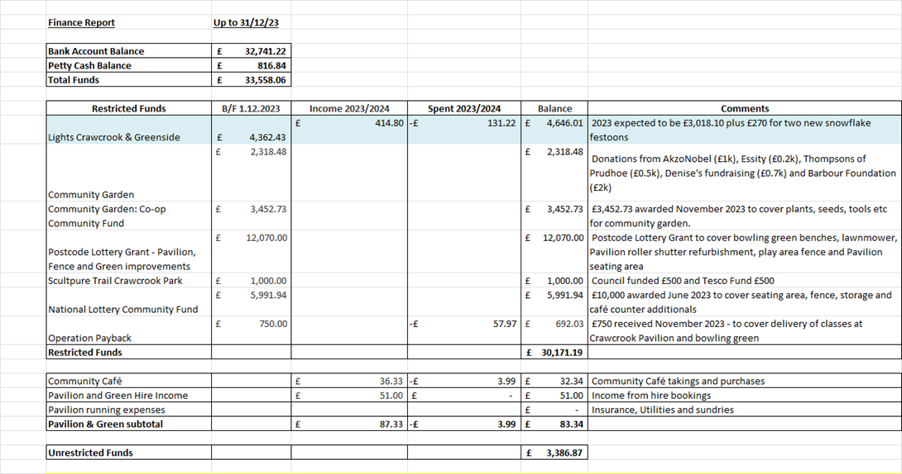
  - There are still funds available for the gardens, and the sculpture funding will need to be spent in the next 6 months.

- Crawcrook Pavilion & Green – Pavilion Subgroup Lead is Laura Clark

  - Pavilion works – No update yet due to the Xmas break. Joiner to be contacted after Xmas (Action Chris)
  - Community Café update – Derrick and Sharon agreed winter opening hours will be Wed/Th/Fri between 2pm and 4pm. (Action LC to repost on FB)
There is the need to monitor the water in the café. Sharon to devise monitoring document. (Action Derrick and Sharon).
  - Warm Spaces (LC) Hopefully will be offered one day per week as Kathryn has completed all the paperwork needed for this,
  - Pavilion and Green hire (LC) –Christmas period activities went extremely well. Thanks to volunteers and Trustees for stepping up and providing these activities.
  - Bowling Green update (LC) – As per previous minutes - No activity until Spring
  - Fence and storage updates. Chris has emailed the Council for a meeting for fence and sculpture trail. (Action Chris)
  - Sculpture Trail (CB) – to follow up as above (Action Chris)

- Review of regular activities:
  - Litter Picking:
    - One volunteer has left.
  - Gardening:
    - Beds around the library to be looked after once the refurbishment of the library has taken place.

- Community Garden Update (LC/BW)
  - Raised beds - One raised bed is being maintained by Emmaville School and the vegetables are growing strong. There will be a new call for who would like to look after the remaining beds via an expression of interest (Action LC via FB)
  - Access issues and gate (LC/BW) –Still issues around access. Councillor Kath not in agreement with the gate access. Discussion followed around security, H &S etc. Next steps – Paddy to email again/appeal, especially as we have a letter of support from the local Emmaville School. (Action Chris to follow up)

- Greenside Plans
General discussion about taking plans forward around volunteer recruitment. Suggestion was made for a meeting at Greenside Club and ask there for community activity suggestions such as a tabletop jumble sale etc. CB stated that two volunteers were interested and that someone would meet with them to explain about Our Villages and activities.

- 2024 Strategic Priorities

  - Volunteers working together – Meeting at Barmoor Hub Thursday 25 January 2024 to discuss what is available in Ryton/Crawcrook. As many Trustees to attend as possible.

- Up and Coming Events – Event Subgroup Lead is Chris Beer

    - Spring Jumble – Tabletop sale. To sell table space. Need to agree a date.
    - Possible Car Boot at St Johns Hall tbc

- A.O.B.:
Discussion around promoting improvement of nature habitats in the community.

- Barbara has applied to the Woodland Trust for hedging.
- Penny suggested workshops at intervals around Birds, Bees and Bats. Could make appropriate living boxes and have a nature talk to raise awareness.

Next scheduled Trustees meeting – Wednesday 7th February 2024 at 7.00 p.m. to be held in Crawcrook Pavilion.

